DAILY WATER INTAKE TRACKER
@CREATIVITY THINK (9483175986/7019689991)

ABSTRACT:
Daily Water Intake Tracker is a web-based application designed to help individuals monitor and maintain proper hydration habits. The platform enables users to log water intake in glasses or milliliters, set daily hydration goals, receive reminders, and track progress through streak charts and tips. Administrators can manage default goals, moderate tip submissions, and view anonymized usage statistics. Built using Django and Django REST Framework for backend operations and React with axios and recharts for frontend interactivity, the system ensures accurate tracking, engagement, and analytics to promote healthy hydration practices..

INTRODUCTION OF THE PROJECT:
Maintaining adequate hydration is essential for overall health, yet individuals often struggle to track water intake consistently. Manual tracking methods are inefficient and prone to errors. The Daily Water Intake Tracker provides a digital solution that allows users to log consumption, receive reminders, monitor progress, and follow simple hydration tips. Administrators can oversee content, moderate public tips, and analyze user engagement to improve the overall effectiveness of the system. The application promotes healthy habits by combining real-time tracking, user notifications, and insightful analytics..

PROJECT OBJECTIVES:

• Enable users to log water intake in glasses or milliliters
• Set and monitor daily hydration goals
• Provide progress visualization with bars and streak charts
• Send timely reminder notifications to users
• Display hydration tips to encourage healthy habits
• Allow administrators to manage default goals and tip content
• Moderate user-submitted tips for quality and relevance
• Track anonymized usage statistics (average intake, active users)
• Export engagement analytics for reporting and insights

PROBLEM OF THE STATEMENT:
Many individuals fail to maintain sufficient hydration due to lack of awareness or proper tracking tools. Existing manual methods or apps may not provide personalized goals, reminders, or analytical insights. This project addresses these issues by providing a structured platform for water intake tracking, goal setting, notifications, and analytics, helping users maintain healthy hydration patterns and enabling administrators to monitor and optimize user engagement..

MOTIVATION OF THE PROJECT:
• To promote healthy hydration habits among individuals and groups
• To provide a simple yet effective digital solution for logging water intake
• To motivate users with reminders, progress tracking, and streak charts
• To offer administrators actionable insights through analytics
• To facilitate moderation and quality control of user-submitted tips
• To improve accountability and encourage consistency in hydration
• To combine health tracking with an interactive and user-friendly interface

BLOCK DAIGRAM OF PROJECT:

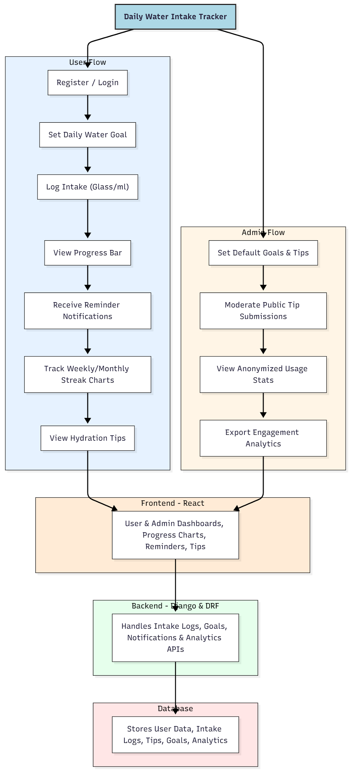

WORKING OF THE PROJECT:
Users begin by registering and setting their daily water intake goals. Each glass or milliliter consumed is logged through the system, updating progress bars and streak charts in real-time. Reminder notifications help users stay on track, while hydration tips guide them toward healthy habits. Administrators set default goals, moderate public tips, monitor anonymized statistics, and export engagement analytics. The backend processes intake data, notifications, and analytics, while the frontend presents dashboards, charts, and tips for an interactive user experience. The database stores all structured user data, logs, and statistics..

SOFTWARE REQUIREMENT:
- Backend:
  - Python 3.x
  - Django
  - Django REST Framework
  - SQLite/PostgreSQL
- Frontend:
  - Node.js and npm
  - React.js
  - Axios
- Development Tools:
  - Visual Studio Code
  - Postman (for testing APIs)
  - Git/GitHub (for version control)
- Server/Deployment (Optional):
  - Gunicorn, Nginx, or Heroku/AWS for hosting

ADVANTAGES OF THE PROJECT:

• Promotes healthy hydration habits
• Tracks daily intake with real-time progress and streaks
• Provides reminders to improve consistency
• Displays tips to encourage proper hydration
• Admins can monitor user engagement and analytics
• Structured storage of user logs and statistics
• Exportable reports for further review
• User-friendly interface for both users and admins

APPLICATIONS OF THE PROJECT:
• Individual wellness tracking
• Fitness groups and health clubs
• Workplace wellness programs
• Wellness-focused apps and services
• Personal health monitoring

REFERENCES:

- Django REST Framework Documentation — Django Software Foundation. Django Documentation. Available: https://docs.djangoproject.com/
- Django REST Framework. DRF Documentation. Available: https://www.django-rest-framework.org/
- React. React Official Documentation. Available: https://reactjs.org/docs/getting-started.html
- Redux. Redux Documentation. Available: https://redux.js.org/introduction/getting-started
- PostgreSQL Global Development Group. PostgreSQL Documentation. Available: https://www.postgresql.org/docs/
- MySQL. MySQL Reference Manual. Available: https://dev.mysql.com/doc/
- Git. Git Documentation. Available: https://git-scm.com/doc
- Node.js. Node.js Documentation. Available: https://nodejs.org/en/docs/
- Axios. Axios Documentation. Available: https://axios-http.com/docs/intro
- Socket.io Documentation – https://socket.io/docs/

